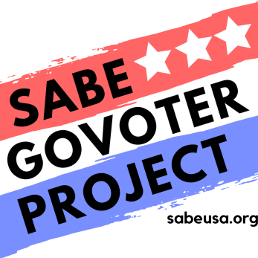
Voters have three ways to vote:
- Mail in Voting
- Early Voting
- Election Day Voting

How do I Vote by mail

- You must first request form online or call a mail in ballot from your Election Office. You can get the request form online and print it out, or call and ask your Election Office and ask them to mail you the form to request a mail in ballot. Some states allow you to complete the request form online.
- Fill in all the required information, sign it, and return the completed request form to your Election Office. The Election Office must receive your request for a mail in ballot before Election Day. You should do it as early as possible so you do not miss the deadline.
- Once the Election Office receives your request, they will mail you a mail in ballot. Some states allow you track your ballot.
- Fill out your ballot and return to the Election Office. You can mail it or drop it off at designated mail drop boxes or the Election Office. To make sure your mail in ballot is counted, your Election Office must receive it by the end of Election Day. Some states require your mail in ballot to be postmarked one day before Election Day or the day of Elections.
- If you are in a hospital or a facility, you can request that someone bring you a ballot. This process can be complicated, you should call your state P&A to get help.
Mail in your ballot as soon as possible to guarantee that it is counted.

How do I Vote Early

Before Election Day, you can vote in person at the early voting locations set by your Election Office.
- Call or check your Election Office website for the location, dates, and hours you can vote early.
- Do not forget to bring your valid ID! Contact your Election Office to find out what documents you need to have
- If you vote Early in person, consider voting during non-peak hours.
- For social distancing, some states have Vote Centers. They are usually located in larger buildings such as sports areas or civic centers

How do I vote on Election Day?
- Times for Election Day voting vary by state. You can go vote anytime during that time period on Election Day.
- You may have to wait in line to vote. Voters who are waiting in line at closing time still get to cast their ballots.
- To avoid standing in long lines, consider voting during non-peak hours
- You must bring valid Identification and will be asked to sign the poll book.
- If you forget to bring identification, you will have to cast a provisional ballot. You may be asked to provide your identification later on in order for your vote to count.
- If you have any questions or issues on voting, you can contact your state P&A. On Election Day, you can call your state P&A’s Voter Hotline.

How do I use Curbside Voting?
Voters who are unable to enter the polling location or voting center may ask that a ballot be brought to them. Two election poll workers, one from each party will assist you. Check with your Election Office for availability.

Your Election Office is receiving guidance from the CDC in their efforts to address the concerns and safety of poll workers and voters.

The SABE GoVoter Project would like to thank Disability Rights Ohio and the Arizona Center for Disability Law for their resources.

